**The Goal: Name Sorter**

Build a name sorter. Given a set of names, order that set first by last name, then by any given names the person may have. A name must have at least 1 given name and may have up to 3 given names.

Logic:

According to the description, the main goal is to sort a random name list alphabetically by the last name. The name consists of last name, one and more given names. So I decide to create a “User” class for each name where we can get the last name from the full name. Plus, for further possible purpose, by using a class to restore the information of users can help easily maintain and develop new features for the application. Then in the main function, there are 3 main steps in the main function which are reading names from <unsorted-names-list.txt>, sort the names and print/write into <sorted-names-list.txt>.

Developing:

Using Microsoft visual studio for coding C# to achieve the goal.

Implement Unit Tests for the application functions.

Using Git as version control as seen here: https://github.com/shenjieqyzx47/Name-Sorter

Using command line for testing.

Codes can be seen in the GitHub link.

Testing:

Example name list test: works ok.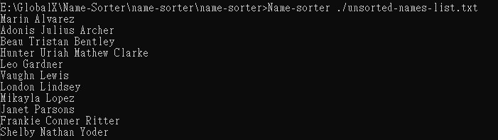

A 500 random name list test: works ok and overwrites the existing sorted-names-list.txt